AUGMENTED INTELLIGENCE
(Augmented intelligence)

A Project Report Submitted
for
Information technology (402)

By

Manish Armoli
Under the guidance of
Mr. Praveen Kumar Joshi

This is to certify that the project entitled “Augmented Intelligence” being submitted to Evergeen Senior Secondary School, Haldwani for the project work of INFORMATION TECHNOLOGY is a record of the work carried by MR. PRAVEEN KUMAR JOSHI under my guidance and supervision.

Date:6/10/2021 Supervisor
MR. PRAVEENJOSHI
TGT Computer
Ever Green Sr. Sec. School, Haldwani
Forwarded By:
MR. M.S. PARWAL
Principal
Ever Green Sr. Sec. School, Haldwani

DEFINITION Of AUGMENTED INTELLIGENCE ?
- Augmented intelligence is a design pattern for a human-centered partnership model of people and artificial intelligence (AI) working together to enhance cognitive performance, including learning, decision making and new experiences.
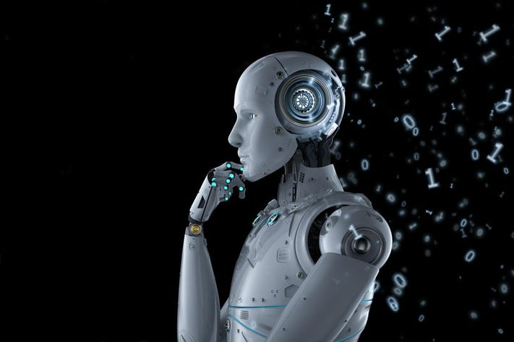

What is Augmented Intelligence.
Augmented intelligence is an alternative conceptualization of artificial intelligence that focuses on AI’s assistive role, emphasizing the fact that cognitive technology is designed to enhance human intelligence rather than replace it. The choice of the word augmented, which means “to improve,” reinforces the role human intelligence plays when using machine learning and deep learning algorithms to discover relationships and solve problems.

Some industry experts believe that the term artificial intelligence is too closely linked to popular culture and science fiction, leading the general public to have unrealistic fears about AI and improbable expectations about how autonomous robots and other intelligent systems will change the workplace and life in general. Researchers and marketers hope the term augmented intelligence, which has a more neutral connotation, will help people understand that AI software will simply improve products and services, not replace the humans that use them.

What is an example of augmented intelligence?

Augmented intelligence and deep learning have applications in any industry that mines big data for patterns and predictive indicators. Examples include the following: Online stores using data analytics to predict customer preferences. Political think tanks using big data analytics to identify undecided voters.

Is AI augmented intelligence?

Augmented intelligence is a design pattern for a human-centered partnership model of people and artificial intelligence (AI) working together to enhance cognitive performance, including learning, decision making and new experiences.

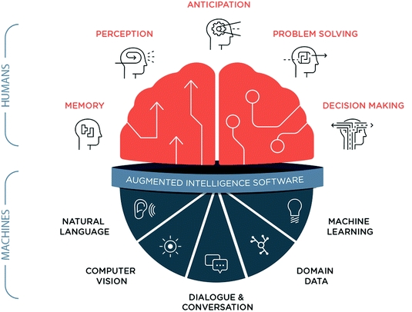
What is AR intelligence?

Augmented reality (AR) is an interactive experience of a real-world environment where the objects that reside in the real world are enhanced by computer-generated perceptual information, sometimes across multiple sensory modalities, including visual, auditory, haptic, somatosensory and olfactory.

What is the difference between AI and AR?
While AR and VR are about interacting with the real world in some way, AI is about systems learning to solve issues that users are having…all by themselves.
What does AR and AI mean?
AR vs. … More businesses are looking for ways to integrate current and emerging technologies—such as Augmented Reality (AR) and Artificial Intelligence (AI)—to enable them to create highly intuitive customer experiences and stay in touch with their audiences.

What is augmented reality AI?
Augmented reality and artificial intelligence (AI) are closely related technologies that app developers can combine to create different experiences. At its core, AR is an experience that combines both digital and physical environments. A quick example of AR are Snapchat lenses and Pokemon Go.


What is augmented reality example?
Augmented Reality Apps are software applications which merge the digital visual (audio and other types also) content into the user's real-world environment. ... Some other popular examples of AR apps include AcrossAir, Google Sky Map, Layar, Locators, SpotCrime, PokemonGo

Which app is used for augmented reality?
Best Augmented Reality Apps
- Houzz (Android, iOS)
- IKEA Place (Android, iOS)
- YouCam Makeup (Android, iOS)
- BBC Civilizations AR (Android, iOS)
- Sketch AR (Android, iOS)

Why do we need augmented intelligence?

Augmented intelligence offers a chance to make more accurate data-driven decisions in science, business, and everyday life. It represents a symbiotic relationship between man and machine. Rather than replacing us, augmented intelligence helps heighten our decision-making ability—and by extension, our intelligence too.

Augmented in education.

Augmented Intelligence method (AUI) in the educational data mining (EDM) context uses the concept of augmented intelligence where the traditional artificial intelligence (AI) supports the decision making, learning or planning of a human.

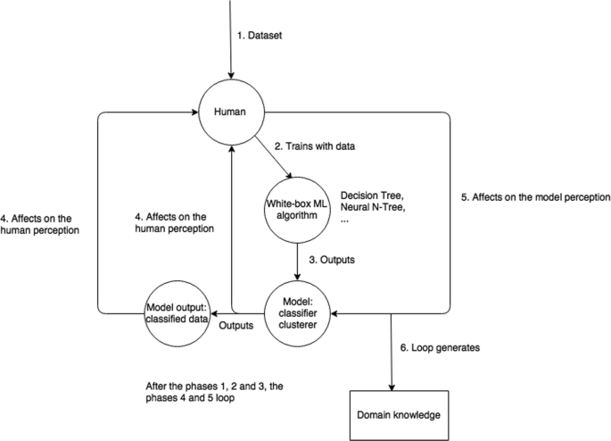
What do you mean by augmented learning?
Augmented learning (AL) is the use of real-life experiences, objects and elements that have been recreated on a computer or mobile device to enhance specific educational concepts. An important goal of augmented learning is to align the instructional platform with each learner’s individual needs.

Augmented learning key ideas.
Instead of providing generalized content, successful augmented learning platforms are context-sensitive and can create learning examples and simulations that are relevant to each user and their specific learning needs.

The key ideas behind augmented learning include the following:

The production of short, interactive learning content that is easy to understand and reinforces lengthier core learning materials;
A move away from traditional just-in-case learning strategies that emphasize repetition and memorization; and
A move toward just-in-time, on-demand learning practices that help the learner address specific skills gaps in real time.
How augmented learning works
In augmented learning, the learning environment is not restricted to a physical location – such as a classroom – but can instead be accessed from a laptop, smartphone or virtual reality headset.

Augmented learning applications use inputs – including voice recognition, touch recognition and optical character recognition (OCR) – and interactions as triggers that signal the delivery of specific, related learning content to the end user. The learning content is then displayed as simple text and videos or as a three-dimensional (3D) virtual world, which students can interact with to discover more details on their topic and enhance their overall learning experience.

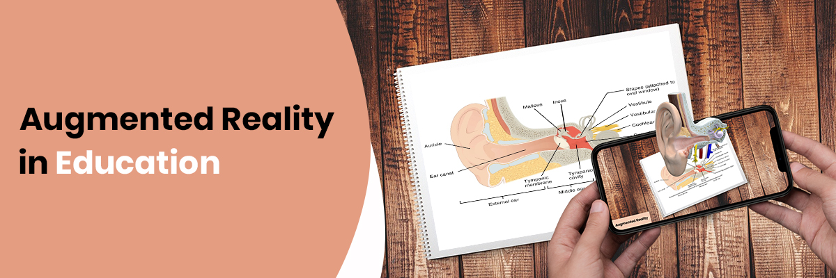

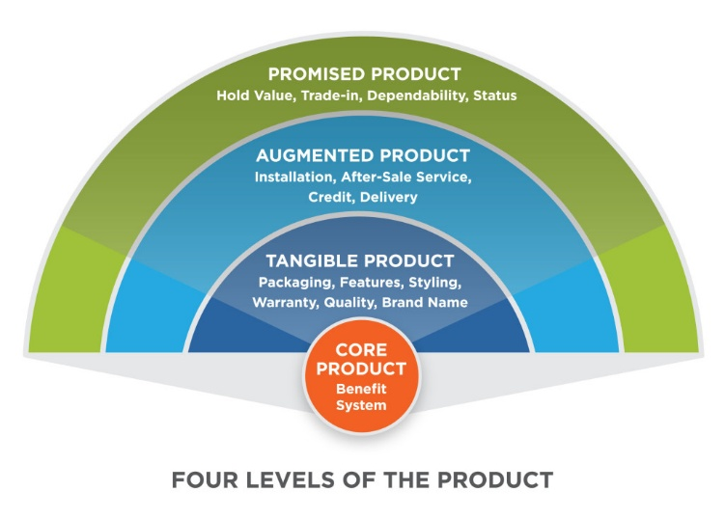
Augmented Benifits

An augmented product has been enhanced by its seller with added features or services to distinguish it from the same product offered by its competitors. Augmenting a product involves including intangible benefits or add-ons that go beyond the product itself.

What is actual product level?

The actual product is the second product level and is quite simple to understand. The actual product is that the overall product design and the product features. If you were to describe a product in detail, then you would be describing its product features – which is the actual product.

What are the 5 product levels?

The five product levels are:
Core benefit: The fundamental need or want that consumers satisfy by consuming the product or service. …
- Generic product: …
- Expected product: …
- Augmented product: …
- Potential product:

Why is augmented product important?
The augmented product plays a vital role in any marketing strategy. … Augmenting your product or service differentiates you from competitors and allows you to find new revenue streams. So, given the importance of the augmented product, our focus now turns to how you can augment successfully.

What is actual product and augmented product?

- Three levels of a product

The core product is defined as the benefit that the product brings to the customer. The actual product refers to the tangible object and relates to the physical quality and the design. The augmented product consists of the measures taken to help the consumer put the actual product to use.

Augmented intelligence benifit in INDIA
Augmented intelligence can assist organizations with revealing new insights, find new opportunities, make new products and services, and define better approaches for working. By understanding their sharpness and flexibility to venture into new areas, they’re finding new markets and clients for their services.

Is augmented intelligence same as artificial intelligence?
Augmented intelligence is like artificial intelligence in the way they both use machine learning to enhance care quality. However, instead of replacing human intelligence, augmented intelligence works to build upon it.


How does help augmented intelligence?

Augmented intelligence offers a chance to make more accurate data-driven decisions in science, business, and everyday life. It represents a symbiotic relationship between man and machine. Rather than replacing us, augmented intelligence helps heighten our decision-making ability—and by extension, our intelligence too.

What is future augmented intelligence reality virtual .

The history of virtual reality and augmented reality technology goes back to 1838, when Charles Wheatstone created his stereoscope, which superimposed an image over each of the user’s eyes, thus creating a distant 3D image. Over the years, Edwin Link’s flight simulator, Morton Heilig’s telesphere mask, Ivan Sutherland’s “Sword of Damocles” VR headset and many more inventions contributed to the cutting-edge technology we recognize today. Of course, the future of virtual reality (VR) and augmented reality (AR) will make our current technology look as primitive as the early experimentations.
Due to extremely high development costs, the complexities of AR/VR devices and other challenges, these technologies are still tiptoe-ing into the commercial world, but early adoption has arrived. So, how close are we to mass adoption?
In Jabil's Augmented and Virtual Reality Technology Trends Survey, technology and business stakeholders indicated that consumer use of AR/VR will see adoption first. Most importantly, almost 70% of respondents believe AR/VR will become mainstream within five years.


What are advantages of having super intelligence?
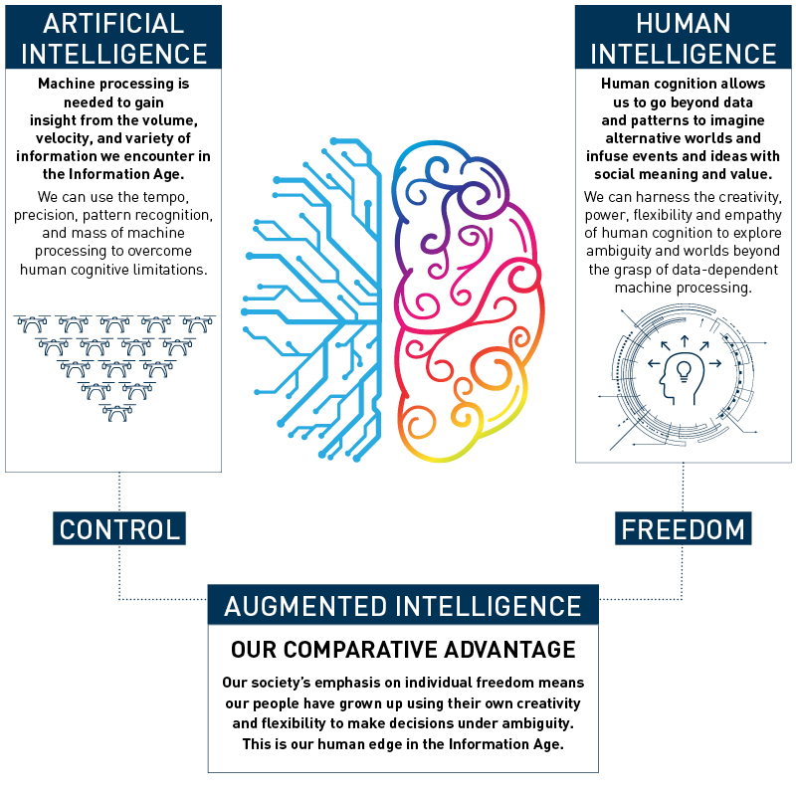
AI drives down the time taken to perform a task. It enables multi-tasking and eases the workload for existing resources. AI enables the execution of hitherto complex tasks without significant cost outlays. AI operates 24x7 without interruption or breaks and has no downtime.

Why is augmented intelligence important?
Augmented intelligence offers a chance to make more accurate data-driven decisions in science, business, and everyday life. It represents a symbiotic relationship between man and machine. Rather than replacing us, augmented intelligence helps heighten our decision-making ability—and by extension, our intelligence too.
How is augmented intelligence used in applications?
Augmented intelligence and deep learning have applications in any industry that mines big data for patterns and predictive indicators. Examples include the following:

- Online stores using data analytics to predict customer preferences.
- Political think tanks using big data analytics to identify undecided voters.
- Medical analysis of case files to identify efficient treatment options.
- Factory automation is overseen by human employees.
- Virtual customer service assistance based on natural language processing.
- Mobile video games using surrounding environments and data to create augmented reality events, superimposing computer-generated images on smartphone camera screens.
- Virtual tutors and instructors for distance education.
- Airplane and drone autopilot systems (pilots are required for takeoff, landing, and unexpected events while autopilots handle the mundane tasks associated with flight).
- Investment and financial applications monitoring and identifying stock market patterns.
Predictive maintenance of factory equipment based on past data

How does augmented intelligence work?
Unlike the traditional view of AI as an autonomous system, operating without the need for human involvement, augmented intelligence uses machine learning and deep learning to provide humans with actionable data.

As a reminder, machine learning describes an AI system’s ability to learn and improve from experience without additional programming. Natural language processing, which allows a computer to identify the human language, is an example of machine learning. And deep learning, sometimes referred to as deep neural learning, describes an AI process that mimics the human brain’s ability to process data and see patterns, much to the felicity of data scientists staring down massive data sets (see below).

